**Timing Diagram**

**ub2232e**

**000874782**

**USMAN BASHARAT**



**Timing Diagrams**

Timing diagrams depict the change in state of one or more elements over time. They can also show the interaction between timed events and the time and duration constraints that govern them.

**Example**

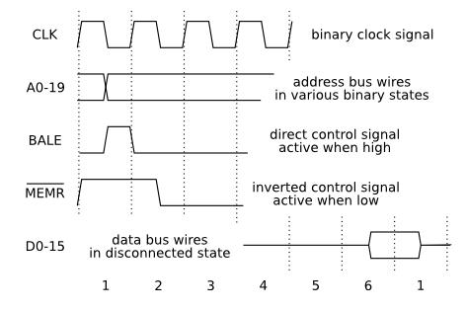

**Exercises**

1. Draw the timing diagram of your pulse.
2. Draw the timing diagram for the Morse message 'Carpe Diem'.
3. Draw the timing diagram, showing the relative relationship of the signals on the four HT leads of a 4 cylinder, four stroke petrol engine running at 4000 rpm..
4. Draw the timing diagram showing the relative relationship of the six signals (North South - Red, Amber, Green. West East - Red, Amber, Green ) controlling the traffic light system at a cross roads.
5. Draw the timing diagram showing the relative relationship of the notes in the following piece of music What is the piece of music?Fur Elise
6. Draw the timing diagram showing for an SR latch (cross coupled NORS), showing the following event sequence. (S = 1, R = 0), (S = 0, R = 0), (S = 0, R = 1), (S = 0, R = 0). The initial state of the latch is S = 0, R = 0, Q = 0, Q = 1